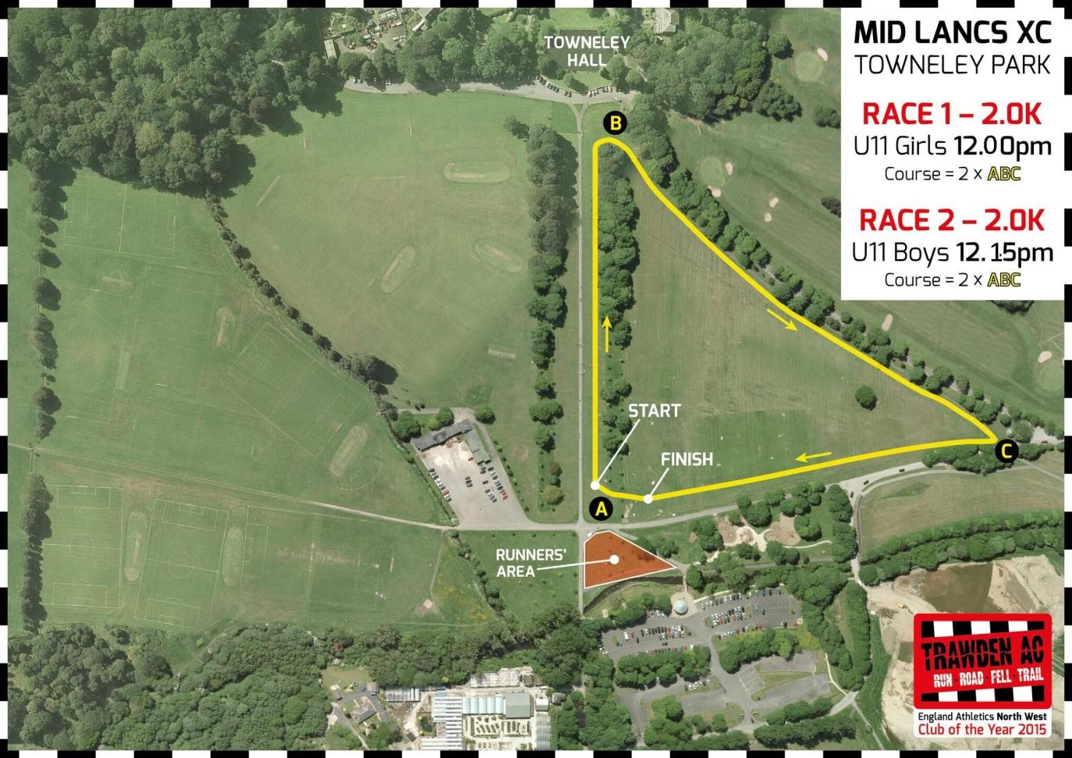
RED ROSE XC LEAGUE
Race 1: 12.15pm Race 2: 12.30pm
Distance: 2k
Course: 2 x ABC
Clayton Le Moors Harriers
RACE 1: Under 11 Boys RACE 2: Under 11 Girls 2 x A B C
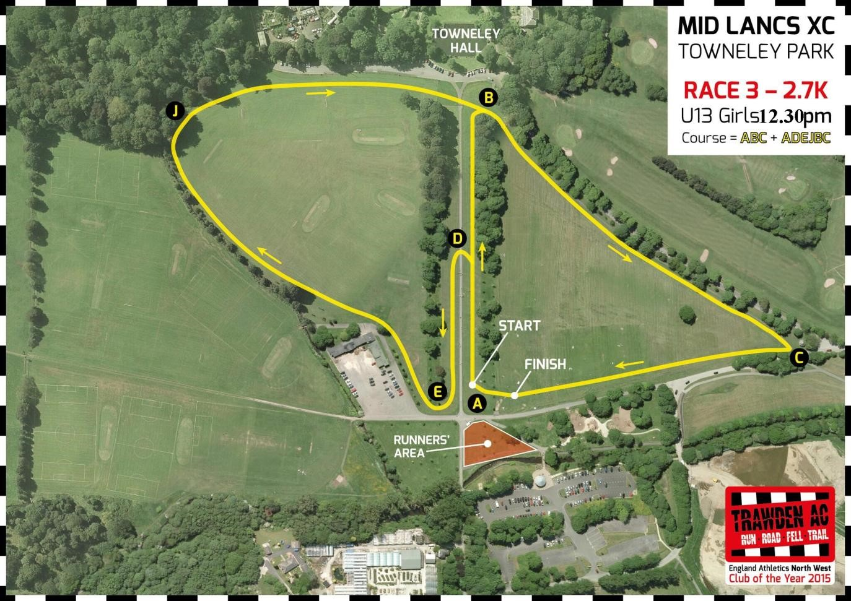
Clayton Le Moors Harriers
RED ROSE XC LEAGUE
Race 3: 12:45pm Race 4: 1:00pm
Distance: 2.7k
Course: ABC + ADEJBC

RACE 3: Under 13 Boys Race 4: Under 13 Girls A B C + A D E J B C

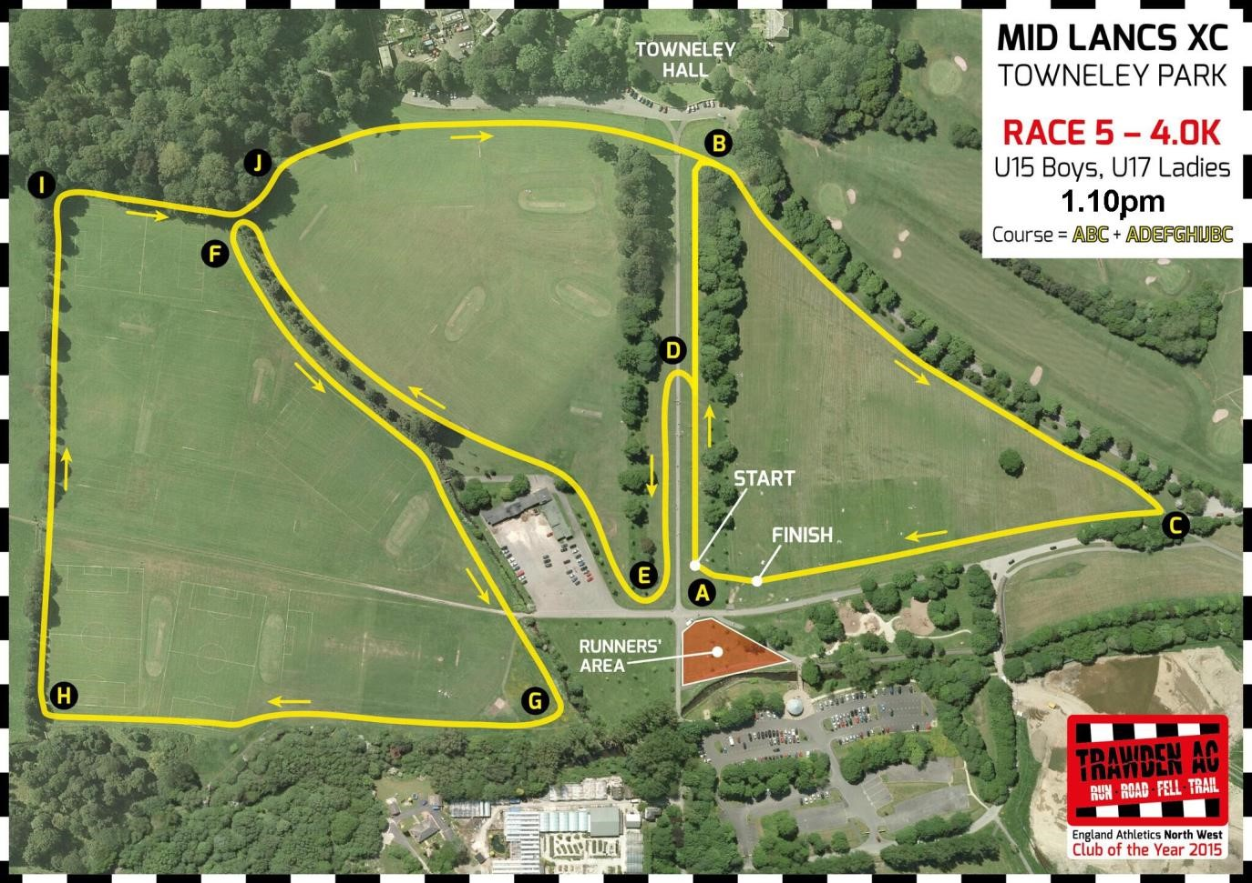
Clayton Le Moors Harriers
RED ROSE XC LEAGUE
Race 5: 1:15pm
Distance: 4k
Course: ABC + ADEFGHIJBC
RACE 5: Under 15 Boys and Girls A B C + A D E F G H I J B C
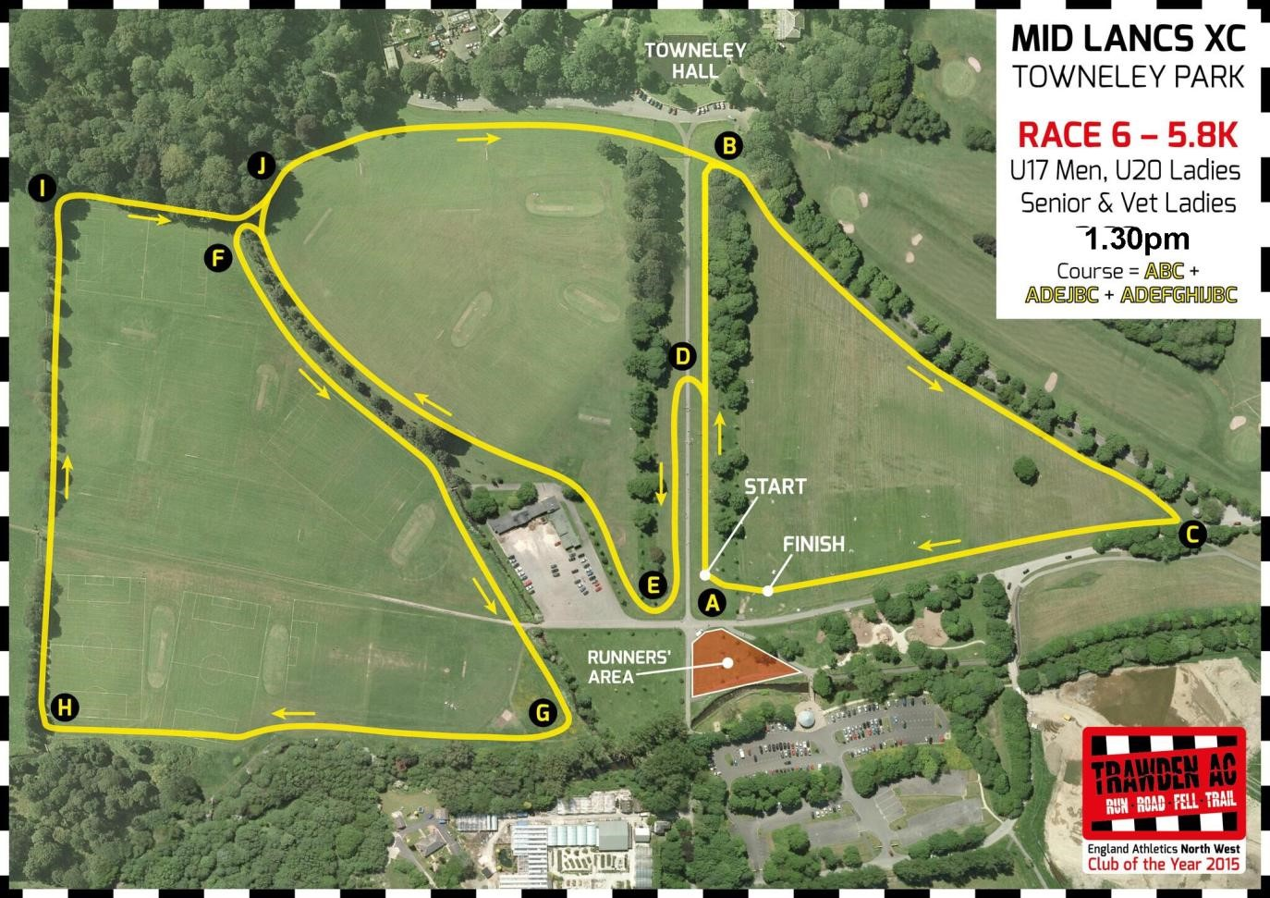
Clayton Le Moors Harriers
RED ROSE XC LEAGUE
Race 6: 1:35pm
Distance: 5.8k
Course: ABC + ADEJBC - ADEFGHIJBC
RACE 6: Under 17 Boys and Girls + Junior, Senior and Vet Women
A B C + A D E J B C + A D E F G H I J B C
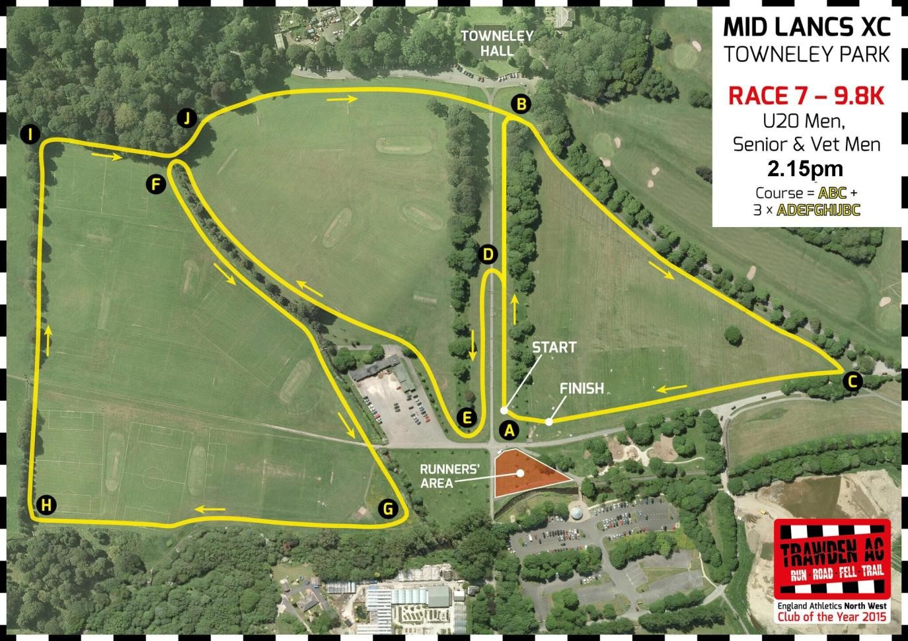
Clayton Le Moors Harriers
RED ROSE XC LEAGUE
Race 7: 2:15pm
Distance: 9.8k
Course: ABC + 3 x ADEFGHIJBC
RACE 7: Junior, Senior and Vet Men A B C + 3 x A D E F G H I J B C

